Image | 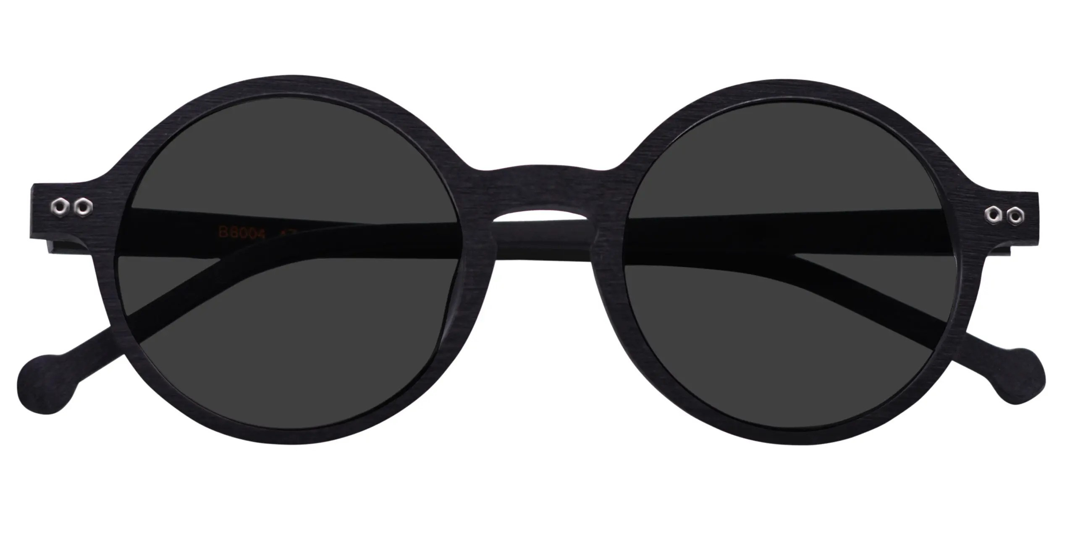
Brand | TOM FORD
Model Name | Riaano P-5026
Price | RS 1200
PRODUCT DETAILS

